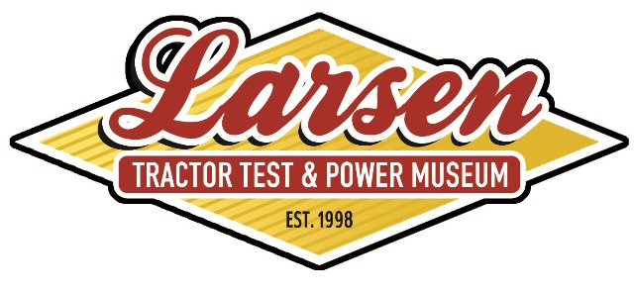
Friends of the Lester F. Larsen Tractor Test & Power Museum
Membership Renewal / Donation Form

Friends of the Larsen Tractor Museum

P.O. Box 830832
Lincoln, NE 68583-0832
Item 1: MEMBERSHIP: Check membership category below. Provide membership information in Box 1.

Name:_________________________________________________

Address:______________________________________________

City:_______________________ State:____ Zip:___________

Phone:________________________________________________

Email:_________________________________________________
_____1 Year Student - $10
_____1 Year Individual - $25
_____1 Year Family - $35
_____1 Year Affiliate Organization - $250
_____1 Life Membership - $1,000
I would prefer to receive museum mailings electronically
and to be contacted via email.
 |  | Box 2: Membership Subtotal
Indicate total amount for membership in Box 2.
Item 2: 2013 DONATION: Your donation is essential; the Larsen Museum relies entirely on private funding.

$1,000 $500 $250 $50 $_____
 |  | Box 3: Donation Subtotal
Indicate total amount for donation in Box 3.
*The Friends of the Larsen Tractor Museum is a 501(c)(3)
nonprofit organization. Memberships and monetary donations are tax deductible.
Indicate total amount enclosed in Box 4.  Please make checks out to: Friends of the Larsen Tractor Museum |  | Box 4: Total for Items 2 and 3
Mail form to the Friends of the Larsen Tractor Museum, P.O. Box 830832 – Lincoln, NE 68583-0832
If you have any questions concerning this form, contact the Larsen Tractor Museum at 402-472-8389.
Thank you for your support!

